One submission per group (2 students) **SE185: Problem Solving in Software Engineering**

**Quiz #5 (100 points)**

|  |  |
| --- | --- |
| Name: Adam Jennissen | Name: |

Answer the following questions and make a pdf file that includes the **source code, sample inputs, and outputs**. You must submit the **pdf file and all of the .c files** on Canvas for full credit. Do not forget to add your group partner name on the pdf file and the source codes.

1. (50 points) Being able to write code concisely can sometimes shorten runtime and therefore make it more efficient. Modify the following code so that it uses loops to scan the user inputs and calculate the averages. Your program must also use an array(s) to store the user inputs and a separate array to store the homework average, exam average, and weighted average. **Your program output must be same as if you run the given code.**

|  |
| --- |
| #include<stdio.h>    int main() {  double hw1, hw2, hw3, hw4, hw5, exam1, exam2, exam3; double hw_avg, exam_avg, weighted_avg;    printf("Enter your grade (%%) for HW #01: "); scanf(" %lf" , &hw1); printf("Enter your grade (%%) for HW #02: "); scanf(" %lf" , &hw2); printf("Enter your grade (%%) for HW #03: "); scanf(" %lf" , &hw3); printf("Enter your grade (%%) for HW #04: "); scanf(" %lf" , &hw4); printf("Enter your grade (%%) for HW #05: "); scanf(" %lf" , &hw5); printf("Enter your grade (%%) for Exam #01: "); scanf(" %lf" , &exam1); printf("Enter your grade (%%) for Exam #02: "); scanf(" %lf" , &exam2); printf("Enter your grade (%%) for Exam #03: "); scanf(" %lf" , &exam3); |

Page **1** of **2**

One submission per group (2 students)

hw_avg = (hw1 + hw2 + hw3 + hw4 + hw5) / 5.0; exam_avg = (exam1 + exam2 + exam3) / 3.0; weighted_avg = (0.40 * hw_avg) + (0.60 * exam_avg);

printf("\nFinal grade = %.2lf%%\n" , weighted_avg); return 0;

}

**Inputs and outputs format:**

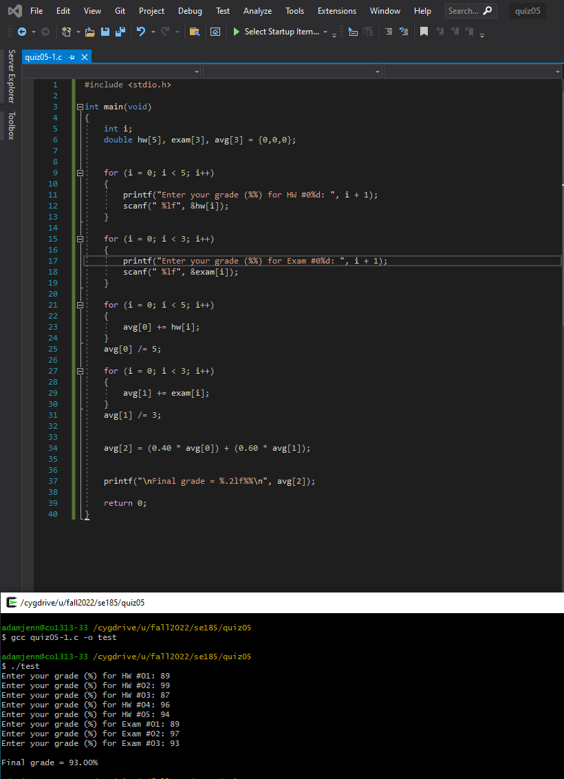

1. **(50 points)** Write a complete C program that uses a 2D array to store the assignment grades of two students (user input) and calculates each student’s final grade by averaging the values. There should be four assignment grades per student and there should be two functions: one to calculate the average, another to determine the letter grade. Please use the following scale for the letter grade:

A: 100-85

B: 84-75

C:74-60 F: 59-0

The program must output the average grade and final letter grade in the following format:

**Sample Inputs and outputs format:**

Page **2** of **2**

